## Module 21 deep-learning-challenge - screen shots v1.docx

Raj Agrawal / SMU DS / Sep 2023

===

All code / information & output is attached as screen shots as well on the github

Starter_Code-pre-processing-Raj..pdf

Alphabet_Soup_Charity_Optimization_Model_2.pdf

===

**Background –** The nonprofit foundation Alphabet Soup wants a tool that can help it select the applicants for funding with the best chance of success in their ventures. With your knowledge of machine learning and neural networks, you’ll use the features in the provided dataset to create a binary classifier that can predict whether applicants will be successful if funded by Alphabet Soup.

From Alphabet Soup’s business team, you have received a CSV containing more than 34,000 organizations that have received funding from Alphabet Soup over the years. Within this dataset are a number of columns that capture metadata about each organization

**## Deliverable :**

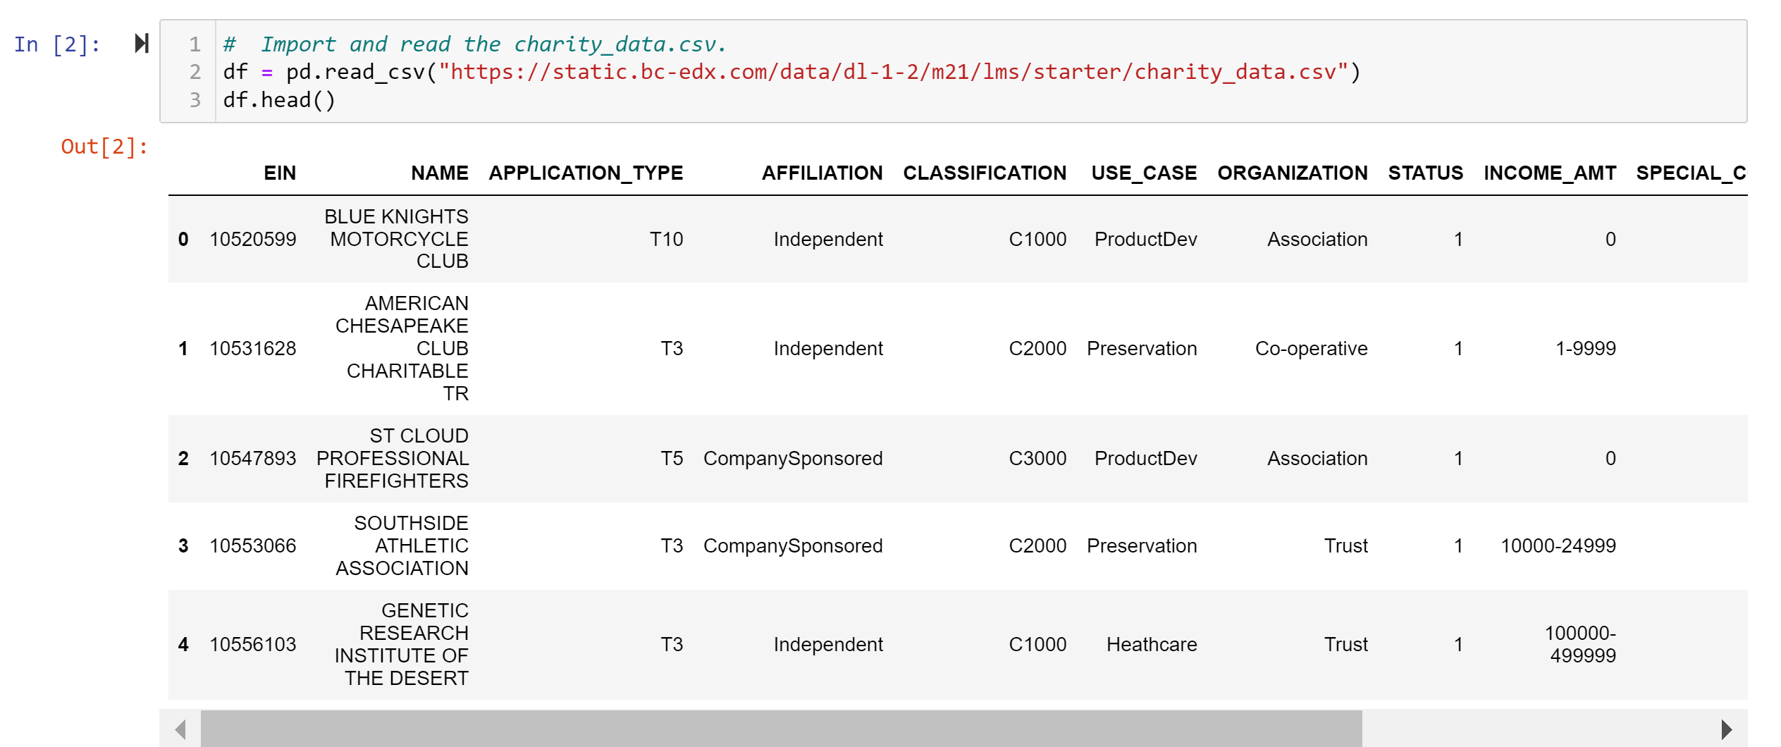

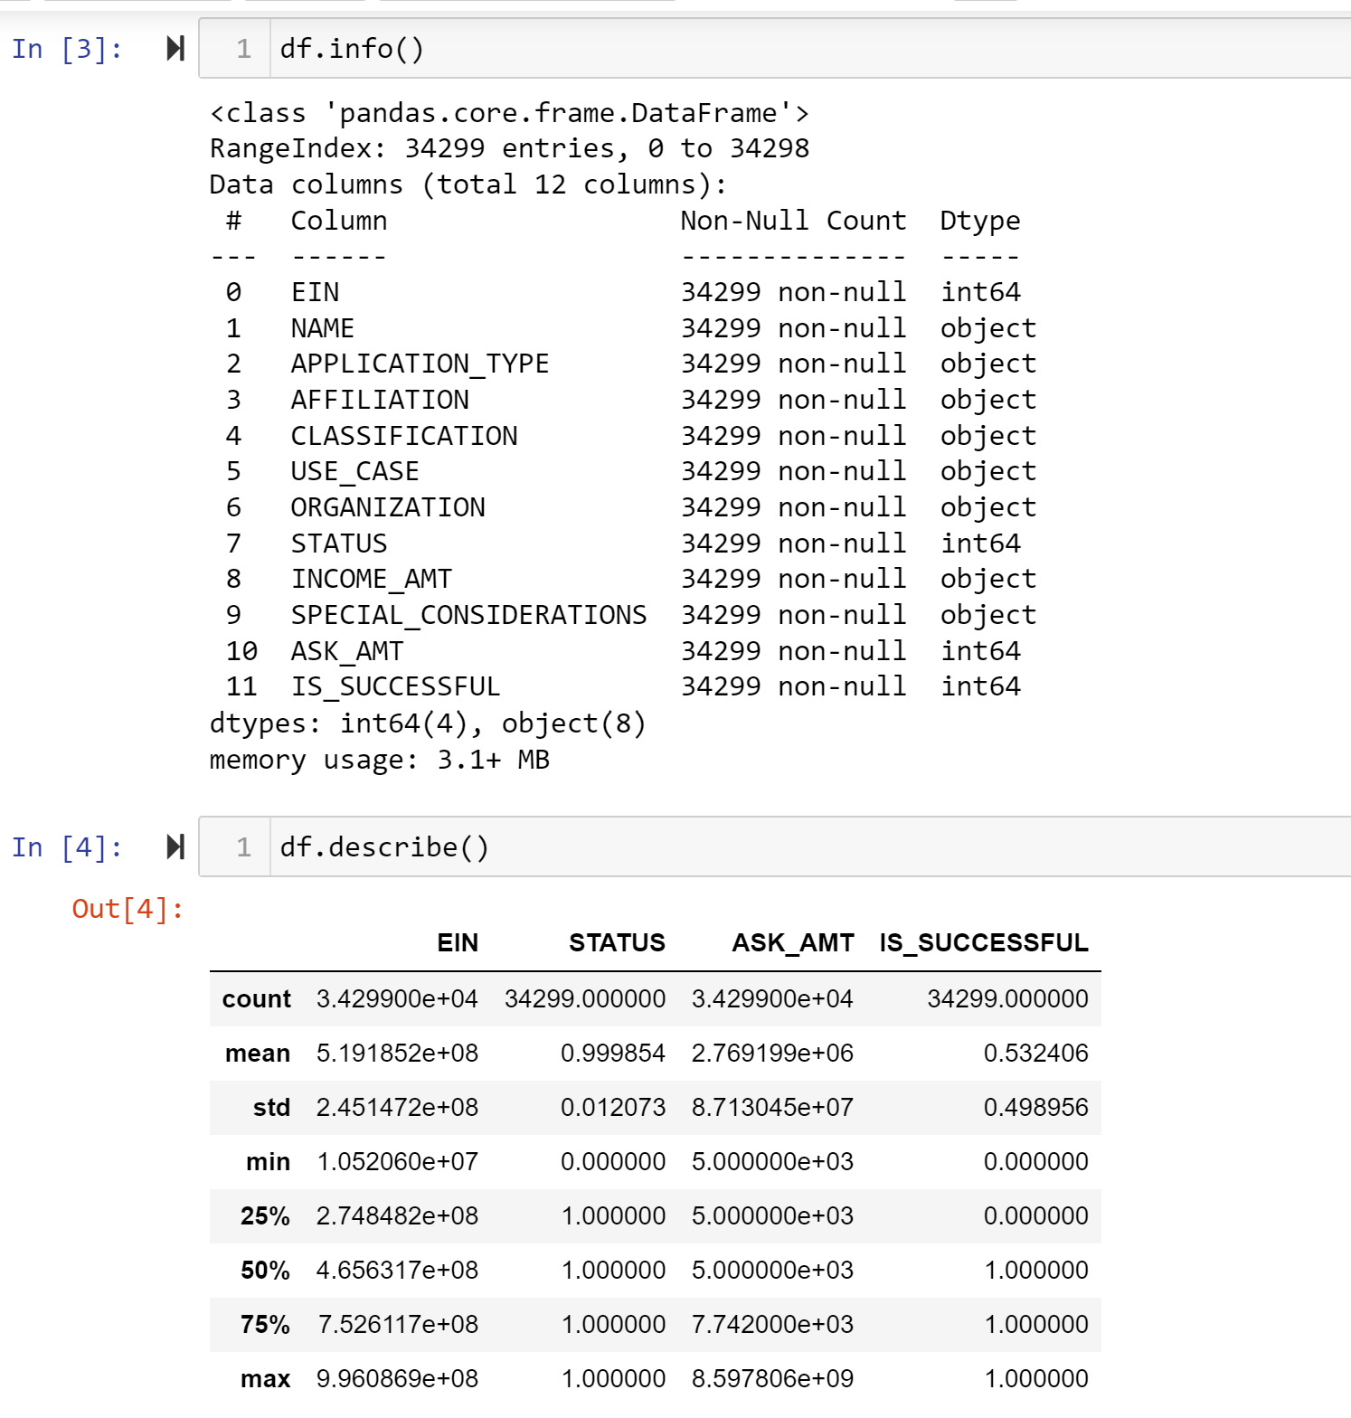

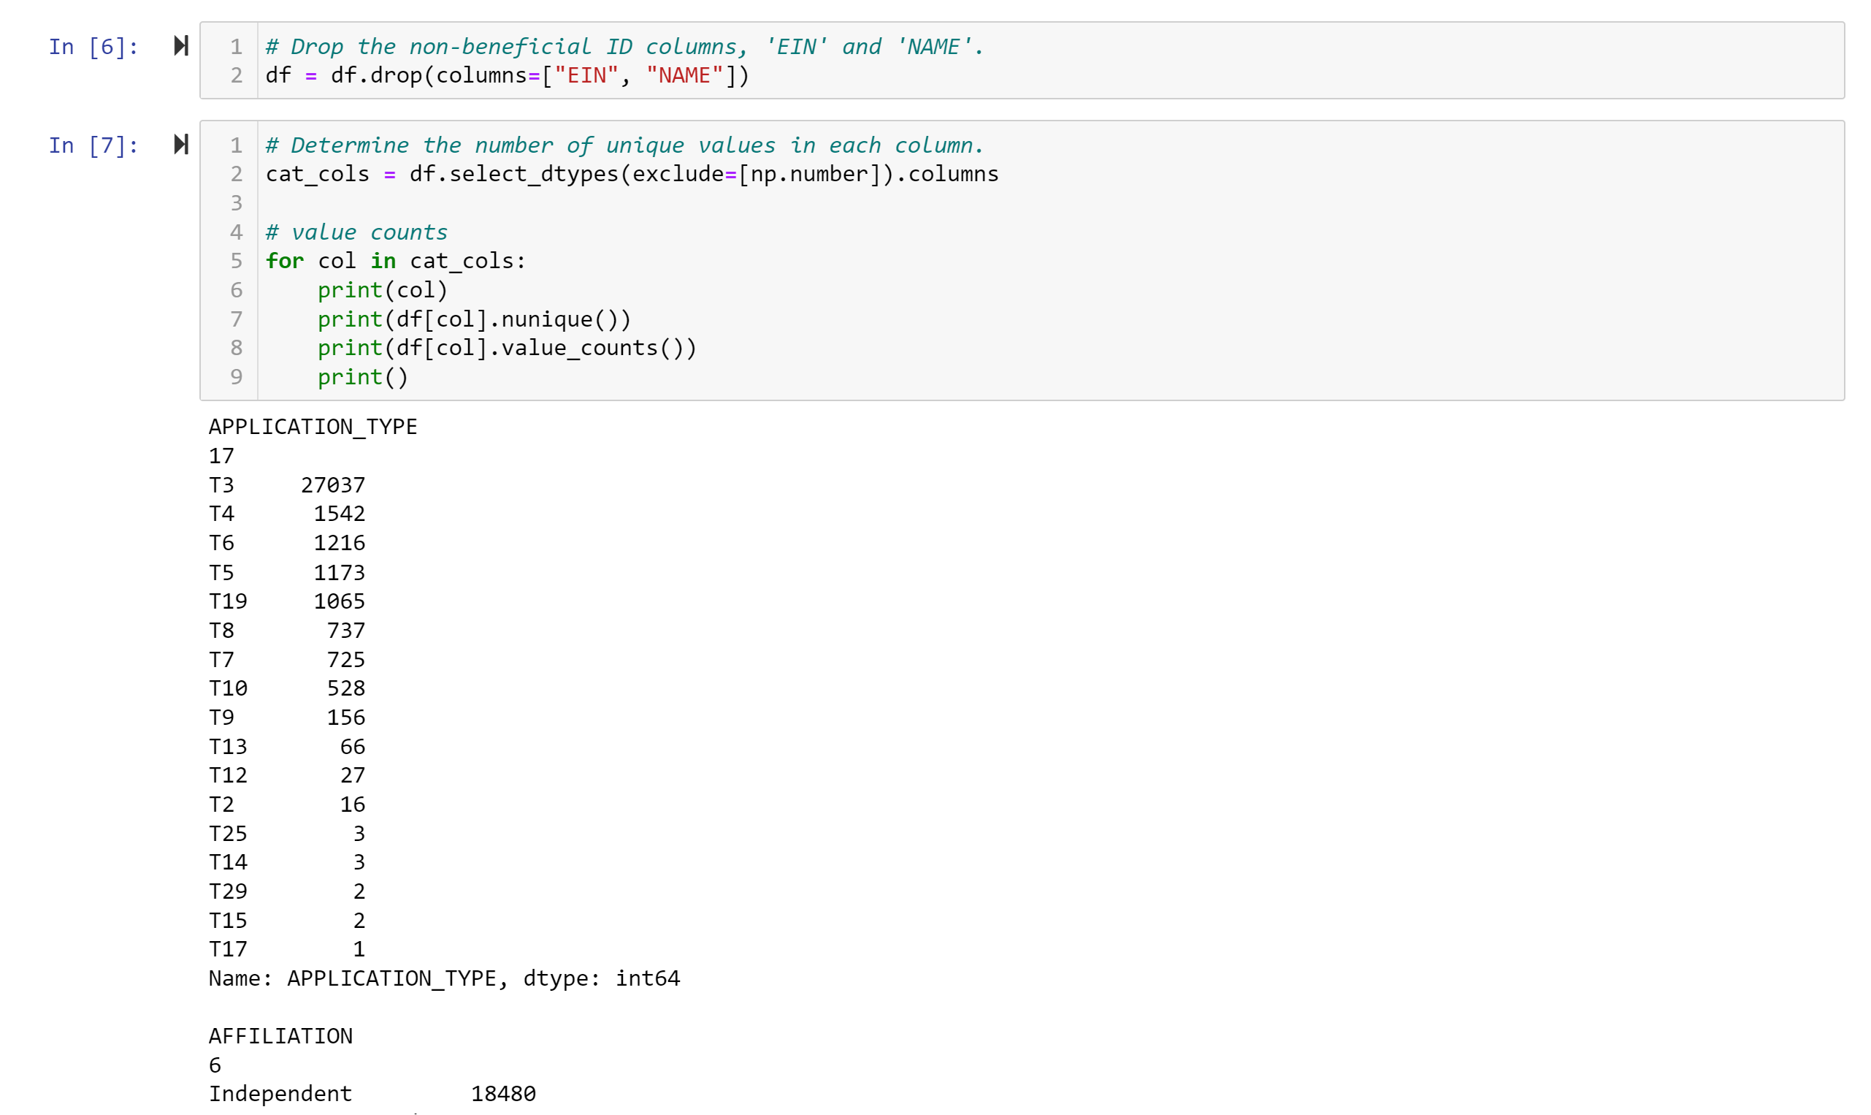

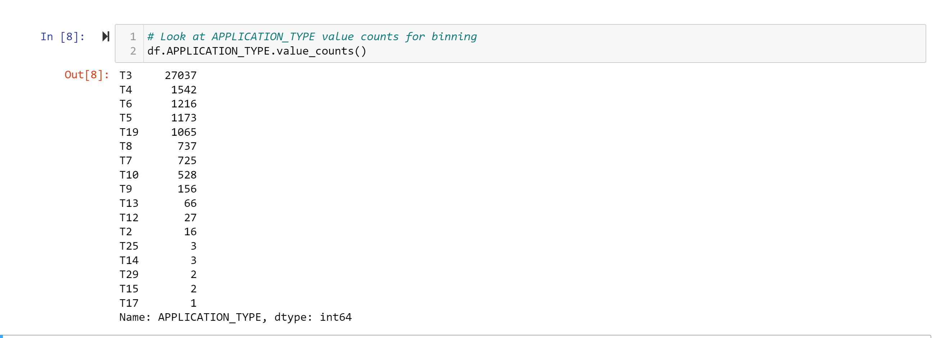

**Readme.md**

**SMU_Bootcamp_2023_Module 21 deep-learning challenge**

Module 21

by  Raj Agrawal / SMU DS / Sep 2023

This activity is the SMU Boot Camp Module 21 Challenge.

All code was resourced from the SMU Boot Camp Class.

CODE IS RUN USING GOOGLE COLABORATORY

Module 21 Challenge

Background

The nonprofit foundation Alphabet Soup wants a tool that can help it select the applicants for funding with the best chance of success in their ventures. With your knowledge of machine learning and neural networks, you’ll use the features in the provided dataset to create a binary classifier that can predict whether applicants will be successful if funded by Alphabet Soup.

From Alphabet Soup’s business team, you have received a CSV containing more than 34,000 organizations that have received funding from Alphabet Soup over the years. Within this dataset are a number of columns that capture metadata about each organization, such as:

EIN and NAME—Identification columns

APPLICATION_TYPE—Alphabet Soup application type

AFFILIATION—Affiliated sector of industry

CLASSIFICATION—Government organization classification

USE_CASE—Use case for funding

ORGANIZATION—Organization type

STATUS—Active status

INCOME_AMT—Income classification

SPECIAL_CONSIDERATIONS—Special considerations for application

ASK_AMT—Funding amount requested

IS_SUCCESSFUL—Was the money used effectively

Step 1: Preprocess the Data

Step 2: Compile, Train, and Evaluate the Model

Using your knowledge of TensorFlow, you’ll design a neural network, or deep learning model, to create a binary classification model that can predict if an Alphabet Soup-funded organization will be successful based on the features in the dataset. You’ll need to think about how many inputs there are before determining the number of neurons and layers in your model. Once you’ve completed that step, you’ll compile, train, and evaluate your binary classification model to calculate the model’s loss and accuracy.

Step 3: Optimize the Model

Using your knowledge of TensorFlow, optimize your model to achieve a target predictive accuracy higher than 75%. Use any or all of the following methods to optimize your model:

Adjust the input data to ensure that no variables or outliers are causing confusion in the model, such as: Dropping more or fewer columns.

Creating more bins for rare occurrences in columns.

Increasing or decreasing the number of values for each bin.

Add more neurons to a hidden layer.

Add more hidden layers.

Use different activation functions for the hidden layers.

Add or reduce the number of epochs to the training regimen.

Step 4: Write a Report on the Neural Network Model

For this part of the assignment, you’ll write a report on the performance of the deep learning model you created for Alphabet Soup. The report should contain the following:

Overview of the analysis: Explain the purpose of this analysis.

Results: Using bulleted lists and images to support your answers, address the following questions:

Data Preprocessing

  What variable(s) are the target(s) for your model?

  What variable(s) are the features for your model?

  What variable(s) should be removed from the input data because they are neither targets nor features?

Compiling, Training, and Evaluating the Model

 How many neurons, layers, and activation functions did you select for your neural network model, and why?

 Were you able to achieve the target model performance?

 What steps did you take in your attempts to increase model performance?

**===**

All code / information & output is attached as screen shots as well on the github

Starter_Code-pre-processing-Raj..pdf

Alphabet_Soup_Charity_Optimization_Model_2.pdf

**#END**